**PROG8080**

**PROGRAMMING: DATABASE MANAGEMENT**

**Assignment: 6**

**Name:** Shravani Gandla

**Student Number:** 8697289

1. A- Create “BestBuy” database.

**QUERY:**

CREATE DATABASE BestBuy;

**Comments:**

The above query shows that, the database is created by using “CREATE DATABASE”.

**OUTPUT:**

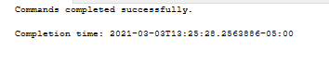

1. B- Create a table with ‘CompID’, ‘Brand’, ’Model’, ‘Price’, ‘RAM’, ‘HDD’, and ‘Description’ columns in your table. The Table’s name must be ‘computers’. (2

point)

* You have to choose the proper data types.

* Add other table’s columns’ properties to make your table design, a smart one.

**QUERY:**

CREATE TABLE computers

(CompID int,Brand varchar(255),Model varchar(255), Price int ,

RAM varchar(255), HDD varchar(255), Description varchar(255));

**Comments:**

The above query shows that, the table is created by using the column names and datatypes .

**OUTPUT:**



1. A- Open the Best Buy website https://www.bestbuy.ca/en-ca/category/

laptops-macbooks/20352.aspx?

1. B- Find 10 laptops (Price ranges between 400 and 2500 CAD). Insert 10 rows to your table using the website’s information.

**QUERY:**

SELECT * FROM computers;

INSERT INTO computers (CompID,Brand,Model,Price,RAM,HDD,Description)

VALUES (14934342,'ASUS','X512JA-BH51-CB',699,'16GB','512GB','1GHz Intel i5-1035G1 quad-core processor (overclockable up to 3.6GHz) and 16GB of DDR4 RAM deliver

reliable processing power and speed to meet your daily computing tasks'),

(15086794,'HP','15-DY2018CA',729,'8GB','512GB','4.2GHz 11th-gen Intel Core i5-1135G7 quad-core processor and 8GB

of DDR4-2666 SDRAM provide a powerful computing performance with to handle your demanding workloads'),

(14934343,'ASUS','X509MA-PH91-CB',469,'8GB','256GB','1.1GHz Intel Pentium Silver N5030 processor

(overclockable up to 3.1GHz) and 8GB of DDR4 RAM deliver reliable processing speed to handle your everyday computing tasks'),

(14538550,'HP','13-ay0008ca',929,'8GB','256GB','IPS,BrightView,Microedge,WLEDbacklit,Multitouch-enabled,

Edge-to-Edge Glass

with Corning Gorilla Glass NBT; 300 nits; 72% NTSC (1920 x 1080)'),

(14655794,'Acer','A515-55-55R6',669,'8GB','256GB','1.0 GHz quad-core Intel Ci5-1035G1

processor and 8GB of DDR4 RAM deliver

excellent performance that makes daily computing and multitasking easy and quick'),

(14637638,'HP','15-ek0018ca',1899,'16GB','1TB','processor with 2.6GHz speed and 16GB

of DDR4-2933 SDRAM (2 x 8GB) delivers powerful performance

no matter what you are playing or working on'),

(1434795,'DELL','XPS9300-75315LV-PCA',1799,'16GB','512GB','1.30GHz Intel Core i7-1065G7 processor with 8MB cache combined with 16GB RAM can handle

performance-demanding applications and provide smooth multitasking Thinner,Lighter,More secure'),

(15202422,'Lenovo','20QFS19W00',2499,'16GB','512GB','Lenovo Thinkpad E15, Intel 10th Gen Core i7 -10510U, 15.6" Full-HD (1920x1080)

IPS 250nits Anti-glare, 16GB DDR4 RAM, 1TB SSD, Windows 10 pro'),

(14428597,'Lenovo','20RD002RUS',1734,'16GB','1TB','

Discrete graphics and a 15.6-inch FHD display, plus state-of-the-art speakers and audio,

mean you won’t miss a thing. And there is extra peace of mind with the built-in security, reliability, and affordability'),

(14965959,'ASUS','UX393EA-XB77T',2299,'16GB','1TB','Handle all your daily tasks with ease with this ASUS ZenBook S Ultra laptop. Powered by an 11th-generation Intel Core i7-1165G7 processor and 16GB of RAM');

**Comments:**

The above query shows that, the data is inserted into the columns using “INSERT INTO” by specific values by using “VALUES” into the columns.

**OUTPUT:**

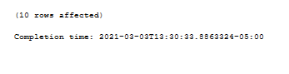

1. A- Query all data from the ‘Computers’ table.

**QUERY:**

SELECT * FROM computers;

**Comments:**

The above query shows that, all the columns are selected by using “SELECT *”.

**OUTPUT:**

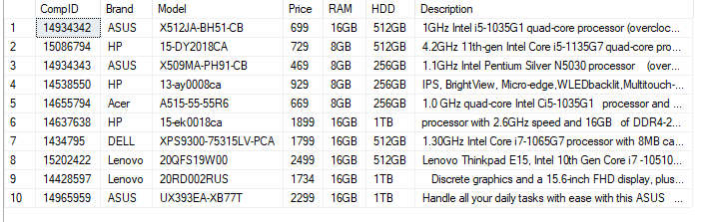

1. B- We are going to buy a laptop, and we have 1200 CAD. Write a query to show all computers between 700 and 1200.

**QUERY:**

SELECT *FROM computers WHERE Price BETWEEN 700 AND 1200;

**Comments:**

The above query shows that, all columns are selected by using “ SELECT * “ By a condition to select the price between the 700 and 1200 using “WHERE” clause.

**OUTPUT:**

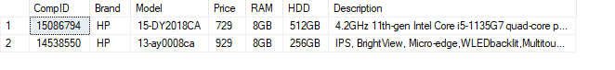

1. C- We need also to see all ‘Dell’, ‘Acer’, and ‘Lenovo’ laptops. (Use IN to

write the query).

**QUERY:**

SELECT * FROM computers WHERE Brand IN ( 'DELL','Lenovo','Acer');

**Comments:**

The above query shows that,all columns are selected by using “ SELECT * “ By a condition to select the Brands of Dell ,Acer, Lenovo using “WHERE” clause.

**OUTPUT:**

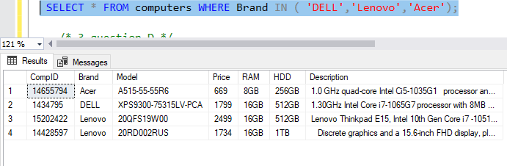

3. D- Show ’Model’, ‘Price’, and reduced price by 10 percent.

* Do not add any column to your table. We need a third column in the result windows which shows prices reduced by 10 percent. Name of the column is: ‘Promotion Price’.

**QUERY:**

SELECT Model,Price ,Price -(Price*0.1) AS PromotionPrice FROM computers;

**Comments:**

The above query shows that, the Model, Price and reduced price as PromotionPrice using an aliase. The price is reduced by 10% using Price-(Price*0.1) from the computers table.

**OUTPUT:**

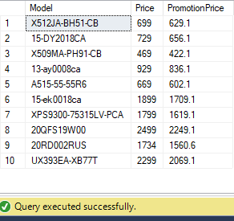

1. A- How many computers have a price more than 1700 CAD? Write a query to show the number of computers with a price more than 2000 CAD.

**QUERY:**

SELECT * FROM computers WHERE Price >1700;

**Comments:**

The above query shows that,all columns are selected by using “SELECT * “ and also an condition of Price >1700 by using “WHERE “ clause from computers table.

**OUTPUT:**



**QUERY:**

SELECT * FROM computers WHERE Price>2000;

**Comments:**

The above query shows that, all columns are selected by using “SELECT * “ and also an condition of Price >2000 by using “WHERE “ clause from computers table.

**OUTPUT:**

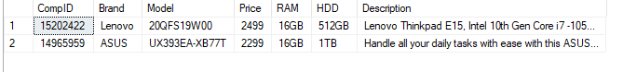

1. B-Delete all computers with prices greater than 2000 CAD, and show the remained computers in our table.

**QUERY:**

DELETE FROM computers WHERE Price >2000 (SELECT * FROM computers);

**Comments:**

The above query shows that, all columns are deleted by using “DELETE “and also a condition of Price >2000 by using “WHERE “clause from computers table and selected all columns from computers.

**OUTPUT:**

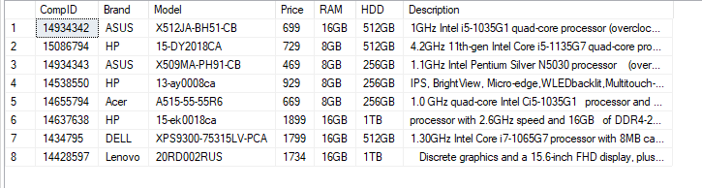

1. A- We need to see all the computer’s information sorted by the price.

**QUERY:**

SELECT Description FROM computers ORDER BY Price;

**Comments:**

The above query shows that, the Description column is selected from the computers table and ordered by Price using an “ORDER BY” clause.

**OUTPUT:**

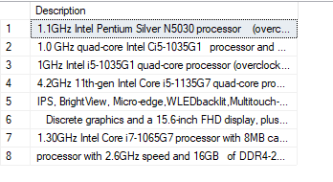

5 B- How many rows exits in your table? Find out using a select command (count function).

**QUERY:**

SELECT COUNT (*) FROM computers;

**Comments:**

The above query shows that, to count the number of remaining rows in the table by using “COUNT”.

**OUTPUT:**

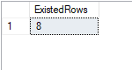

1. C- Add the second table. Name it ‘customers’ with CusID, First Name, last

name, City.

**QUERY:**

CREATE TABLE customers(CusID int,FirstName varchar(255),LastName varchar(255),City varchar(255) );

**Comments:**

The above query shows that, the table is created using “CREATE TABLE “ with column names and datatypes.

**OUTPUT:**

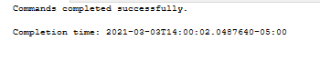

1. D- Add five customers to your table.

**QUERY:**

INSERT INTO customers (CusID,FirstName,LastName,City)

VALUES(1,'Teju','Maram','Hanamkonda'),(2,'Shravani','Gandla','Mallial'),(3,'Akhila','Chintha','Ghanpur'),(4,'Supriya','Mudhamalla','Jagitial'),(5,'Shruthi','Myadari','Karimnagar');

**Comments:**

The above query shows that,the columns are inserted into the table by using “INSERT INTO” and their values by “VALUES”.

**OUTPUT:**

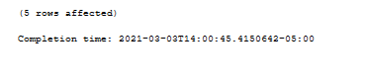

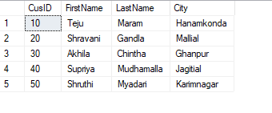

1. A- Add The third table. Name it ‘Sales’. The columns are: ID, CusID, CompID, Date, Quantity.

**QUERY:**

CREATE TABLE Sales (ID int,CusID int, CompID int,Date Date,Quantity int);

**Comments:**

The above query shows that, the table is created using “CREATE TABLE “ with column names and datatypes.

**OUTPUT:**

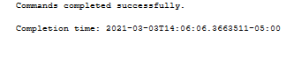

1. B- Add 10 sales to your table. It is important to use the same ComID and CusID you used in computers and customers tables.

**QUERY:**

INSERT INTO Sales (ID,CusID,CompID,Date,Quantity)

VALUES (1,10,14934342,'2005-10-30',5),(2,20,14934343,'2002-09-30',2),

(3,10,14934343,'2006-09-30',3),(4,20,14538550,'2000-09-20',8),(5,40,14538550,'2005-02-20',10),(6,30,14637638,'2009-12-12',5),(7,50,14965959,'2012-05-13',6),

(8,30,15202422,'2015-09-3',12),(9,50,14428597,'2000-08-20',5),(10,40,14655794,'2015-02-10',2);

**Comments:**

The above query shows that, the columns are inserted into the table by using “INSERT INTO” and their values by “VALUES”.

**OUTPUT:**

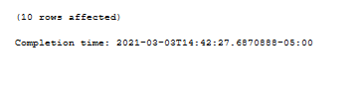

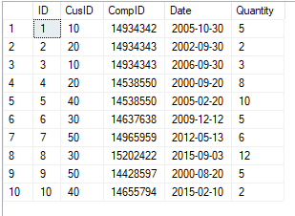

1. C- Change the the Ram of all ‘Dell’ computers to 8.

**QUERY:**

UPDATE computers SET RAM = '8GB' WHERE Brand = 'DELL';

**Comments:**

The above query shows that,the column is updated b y using “UPDATE” and condition brand =”DELL” by using “WHERE” clause.

**OUTPUT:**

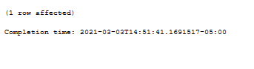

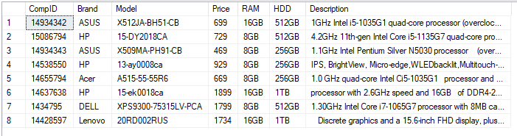

6 D- Change the last customer’s last name to ‘Jackson’.

**QUERY:**

UPDATE customers SET LastName = 'Jackson' WHERE LastName = 'Myadari';

SELECT * FROM customers;

**Comments:**

The above query shows that, the column is updated by using “UPDATE” and condition LastName = ‘Mydari’ by using “WHERE” clause and selected all the columns from the customers table.

**OUTPUT:**

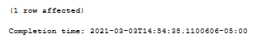

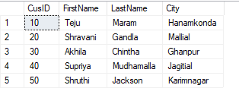

1. A- We need to know the name of the customers who bought computer with the model of the computer they bought.

**QUERY:**

SELECT customers.FirstName,customers.LastName,computers.Model,Sales.CusID

FROM((Sales INNER JOIN computers ON Sales.CompID= computers.CompID) INNER JOIN customers ON Sales.CusID = customers.CusID);

**Comments:**

The above query shows that, the columns firstname,lastname,model from customers table and CusID from Sales table. And joined computers and sales table by using “INNER JOIN”.

**OUTPUT:**

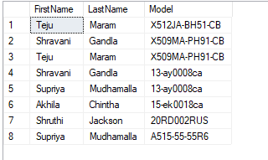

1. B- We also need to know the date and the price of the computers to be displayed with the name and CusID of the customers.

**QUERY:**

SELECT customers.FirstName,customers.LastName,Sales.Date,computers.Price,customers.CusID FROM((Sales INNER JOIN computers ON Sales.CompID= computers.CompID) INNER JOIN customers ON Sales.CusID = customers.CusID);

**Comments:**

The above query shows that, the firstname,lastname,CusID are selecte from customers table and Date from Sales table.And joined both the tables by using “ INNER JOIN” , an condition Sales.CusID = customers.CusID

Using “ON” clause.

**OUTPUT:**

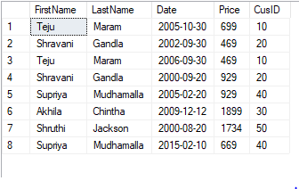

7C- Which computers did not sold at all?

**QUERY:**

SELECT computers.Brand FROM computers LEFT JOIN Sales ON computers.CompID= Sales.CompID where Sales.CompID is null order by computers.Brand;

**Comments:**

The above query shows that,the column Brand is selected from computers table and joined to sales table using “LEFT JOIN “ to get the information .A condition computers.CompID= Sales.CompID by using “ ON “ and where condition Sales.CompID is null and ordered by Brand.

**OUTPUT:**

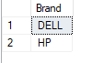

1. A . Add a new sales to the sale table. Use the current date as the sale date. (Do not forget to use proper CusID and ComID).

**QUERY:**

INSERT INTO Sales (ID,CusID,CompID,Date,Quantity)

VALUES (1,20,14428597,'2020-03-03',5);

**Comments:**

The above query shows that, the columns are inserted into the table by using “INSERT INTO” and their values by “VALUES”.

**OUTPUT:**

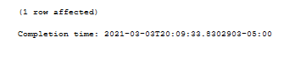

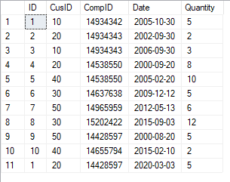

1. B. Find the first selling date and last selling date. Find out the difference between two date values?

**QUERY:**

SELECT DATEDIFF(day,(SELECT MIN(Date) FROM Sales),(SELECT MAX(Date) FROM sales)) AS DateDifference;

**Comments:**

The above query shows that, the first date and last date is selected by using Min(date) and Max(date) “SELECT “and the difference between the two date values is extracted by “DATEDIFF”.

**OUTPUT:**

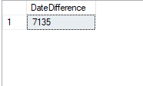

1. A. Find the lowest computer price and use it as a subquery to find the customers buying the computer with the lowest Price.

**QUERY:**

SELECT customers.FirstName,customers.LastName,customers.CusID FROM customers WHERE CusID = (SELECT CusID FROM Sales WHERE CompID = ( SELECT TOP 1 CompID FROM computers ));

**Comments:**

The above query shows that,the columns firstname,lastname,cusID are selected from customers table by using “ SELECT” and condition by using “ WHERE” and a subquery in it.

**OUTPUT:**

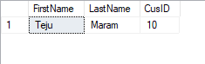

1. B. We need to know if there are customer name having ‘e’ or ‘a’ in their last names. If there are any customers by that name, find out if they bought any ‘Dell’ computers?

**QUERY:**

**Comments:**

The above query shows that,

**OUTPUT:**